Safety and Lab Equipment Quiz Review 14 – 15

I) Name and state the purpose of each piece of lab equipment.
1. 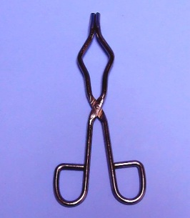 2. 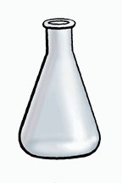 3. 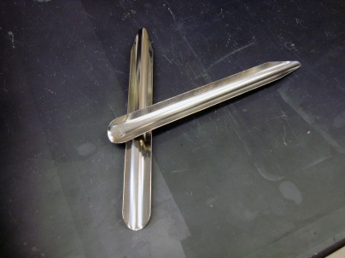 4. 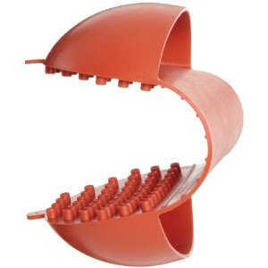

5. 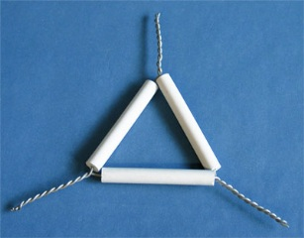 6. 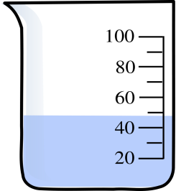 7. 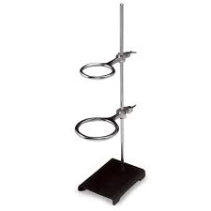 8. 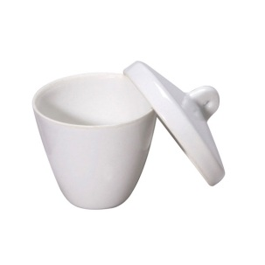

9. 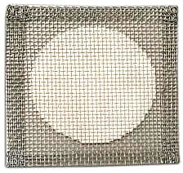 10. 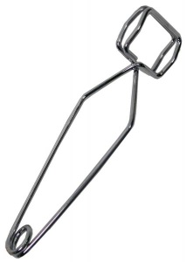 11. 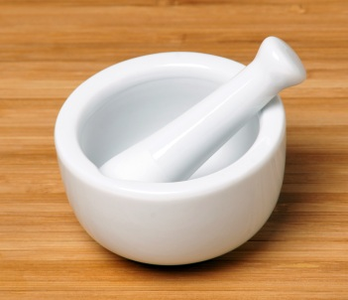 12. 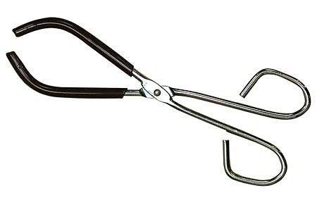

13. 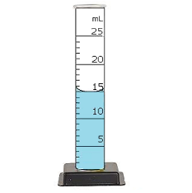14. 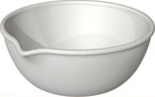 15. 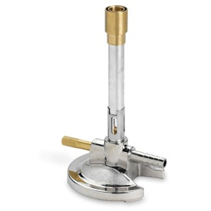 16. 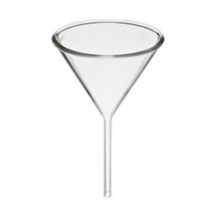

17. 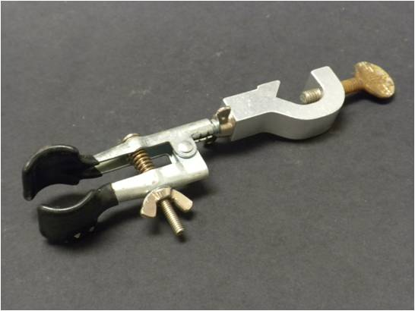 18. 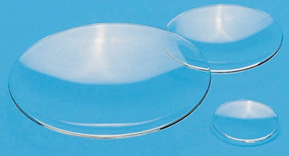 19. 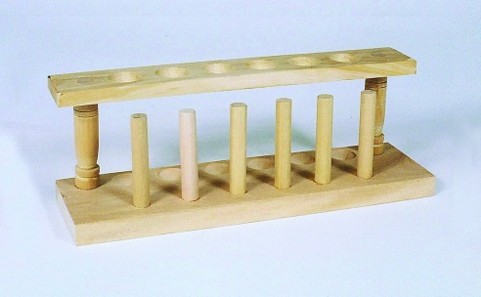

II) Short answer

20. What are the two most important pieces of safety equipment you must put on when performing any lab experiment?
21. What is the technique called that allows you to safely check for any fumes produced by a chemical reaction?

22. What is the name of the substance used to neutralize an acid spill? Where can it be found in the lab?

23. Where do you place broken glassware, and how do you safely handle it?

24. Complete the phrase, Do as you otter, add ____________ _____________ ________________.

25. How do you safely heat a test tube in a flame? What should you use to hold it?

26. In what condition (three checkpoints) should you return equipment to the cabinets?

27. What technique is used to tell whether or not glassware or equipment is still hot?

28. Where is the hottest part of a burner flame?

29. How do you know if the gas jet is turned off?

30. Which pieces of lab equipment can accurately measure volumes of liquids?

31. What is a reagent bottle? How do you avoid contaminating the bottle?

32. What procedure do you use to safely weigh something on an electronic balance?

33. What do you call the technique used to pour a liquid from one container to the next without spilling? How do you do it?

